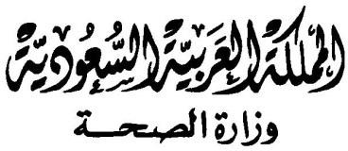

االدارة العامة ملكافحة عدوى املنشآت الصحية

Brief ICU Report COVID19 Cases

|  |  |
| --- | --- |
| **Region** |  |
| **Name of patient** |  |
| **Age** |  |
| **Gender** |  |
| **Nationality** |  |
| **ID/Iqama** |  |
| **Job category** |  |
| **HESN** |  |
| **Date of notification** |  |
| **Date of result of swab** |  |
| **Name of admission hospital** |  |
| **Name of Working hospital** |  |
| **Date of admission** |  |
| **Date of ICU admission** |  |
| **Status: critical/ stable** |  |
| **Intubation: yes / No** |  |
| **If intubation-Date of intubation** |  |
| **Chronic diseases** |  |
| **Source of infection** |  |
| **Vaccinated ( Yes/No)** |  |
| **Type of Vaccine** |  |
| **1st dose less than 14 days** |  |
| **1st dose more than 14 days** |  |
| **Full dose more than 14 days** |  |